**Grocery App Report**

**Introduction :**

**1.1Overview :**

This is an android app that helps you to make a list of grocery items along with its price and quantity.

**1.2Purpose :**

We are humans and we cannot remember everything. We sometimes forget the things that we want to buy. However, with the assistance of this app you can make a list of grocery items you intend to buy so that you don't forget anything and also have a track of your expenditure for budget maintenance.

**2 Literature Survey :**

**2.1 Existing Problem**

Users frequently forget items to buy because of which they have to run to shops again and again which is quite a frustrating and tiring situation and if our expenses crosses out budget while shopping that could be a matter of concern.

**2.2 Proposed Solution**

To overcome this problematic situation I built a grocery app which helps you to list down all the item that you need to buy along with its price.

**3 Theoretical Analysis:**

**3.1 Block Diagram**

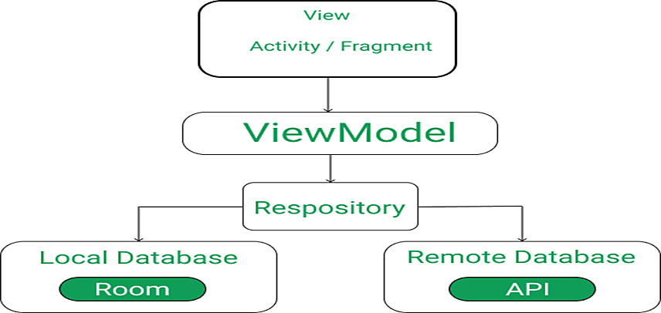

**3.2 Hardware/Software designing**

● Windows 10 OS

* An Android device or emulator

● Android Studio Manage Products Add Product Delete Product

**4 Experimental Investigation:**

In this project MVVM (Model View ViewModel) was used for architectural patterns, Room for database, Coroutines and RecyclerView to display the list of items. **LiveData:** A data holder class that can be observed. Always holds/caches the latet version of data, and notifies its observers when data has changed. LiveData is lifec-ycle aware. UI components just observe relevant data and don't stop or resume observation. LiveData automatically manages all of this since it's aware of the relevant lifecycle status changes while observing. **ViewModel:**Acts as a communication center between the Repository (data) and the UI. The UI no longer needs to worry about the origin of the data. ViewModel instances survive Activity/Fragment recreation.

**Repository:** A class that you create that is primarily used to manage multiple data sources.

**Entity:** Annotated class that describes a database table when working with Room.

**Room database:**Simplifies database work and serves as an access point to the underlying SQLite database (hides SQLiteOpenHelper). The Room database uses the DAO to issue queries to the SQLite database.

**SQLite database:** On device storage. The Room persistence library creates and maintains this database for you.

**DAO:**Data access object. A mapping of SQL queries to functions. When you use a DAO, you call the methods, and Room takes care of the rest.

**RecyclerView:** It is a container and is used to display the collection of data in a large amount of dataset that can be scrolled very effectively by maintaining a limited number of views. **Coroutines:** Coroutines are lightweight thread, we use a coroutine to perform an operation on other threads, by this our main thread doesn't block and our app doesn't crash.

**5 Flowchart:**

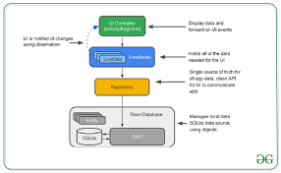

**6 Result:**

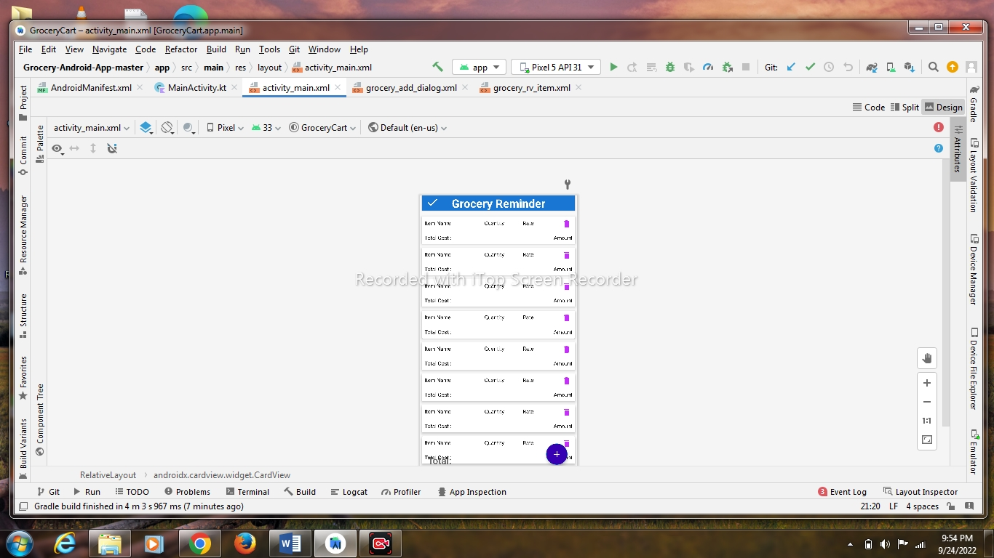

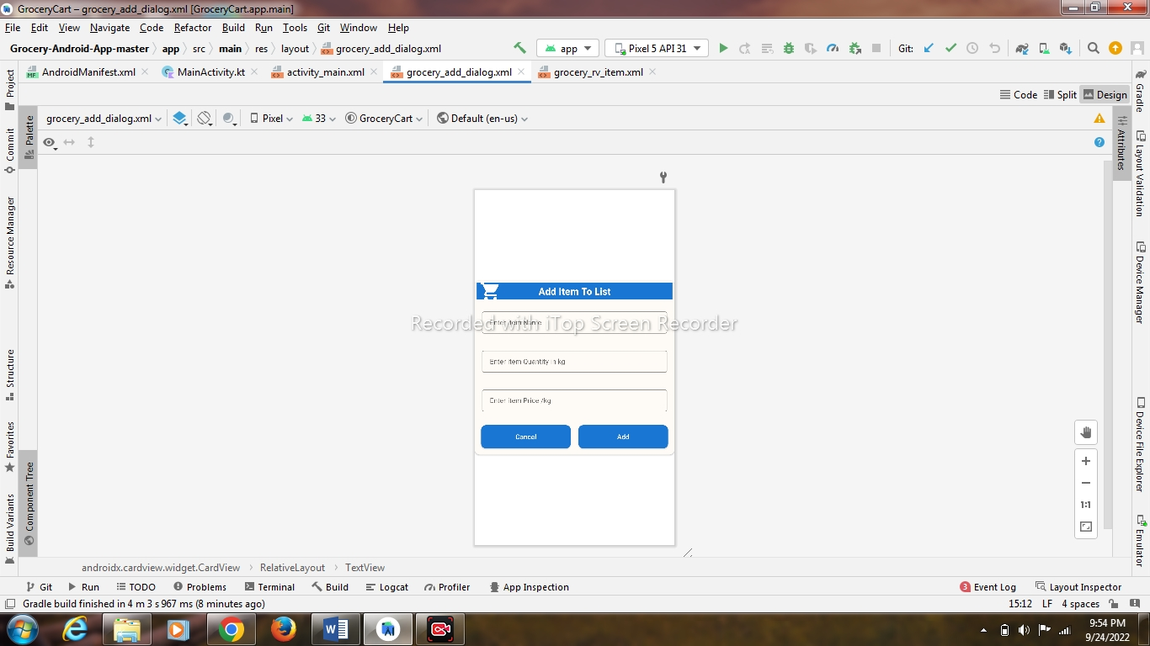

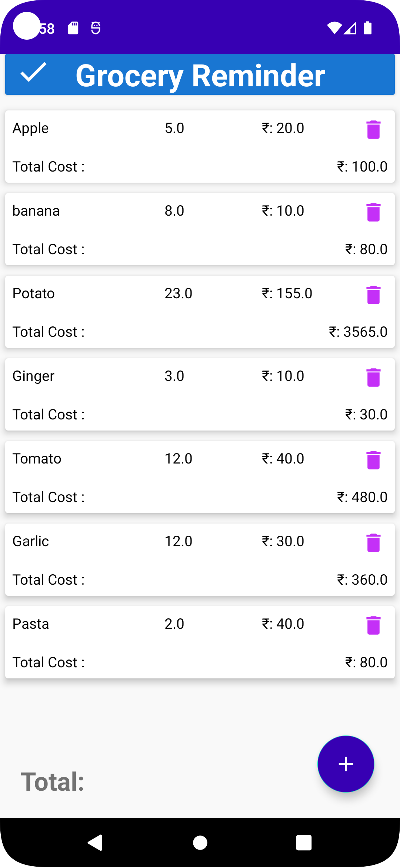

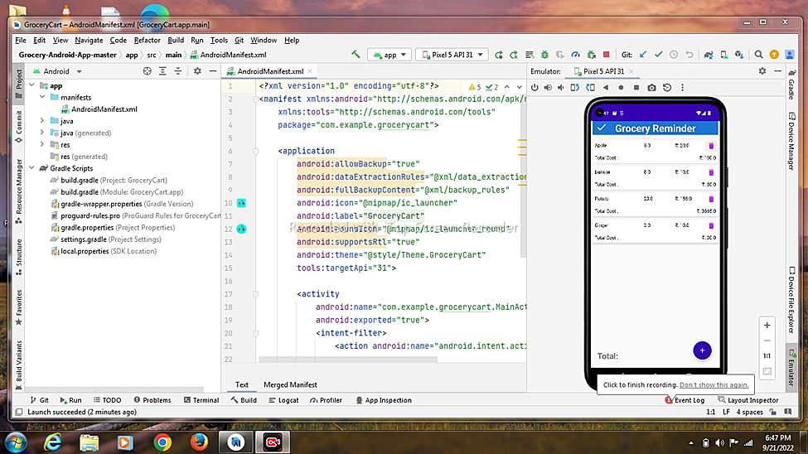

**7. Conclusion:**

This project helped me to clear my concepts on Room Database, Coroutines, MVVM, etc. This project would help me not just as a developer to learn new and interesting things but also as a user we generally forgets items to purchase while shopping. Working on this project made me confident enough to apply my knowledge on android app development and create such an app. I have used Kotlin to build this application. All the functionality is coded in the classes and interfaces created and the layout is designed using xml.

**8. Reference:**

● Google: <https://www.google.com/>

● Geeksforgeeks: <https://www.geeksforgeeks.org/how-to-build-a-grocery-androidapp-using-mvvm-and-room-database/>

● Android Developer: <https://developer.android.com/codelabs/android-room-witha-view-kotlin#0>

● YouTube: <https://www.youtube.com/watch?v=vdcLb_Y71Ic>

● SmartInternz: <https://smartinternz.com/Student/guided_project_workspace/64543>

**9. Appendix:**

**9.1 Source Code:**

**Activity_main.xml**

*<?*xml version="1.0" encoding="utf-8"*?>*<RelativeLayout xmlns:android="http://schemas.android.com/apk/res/android"  
 xmlns:app="http://schemas.android.com/apk/res-auto"  
 xmlns:tools="http://schemas.android.com/tools"  
 android:layout_width="match_parent"  
 android:background="#F9F9F9"  
 android:layout_height="match_parent"  
 tools:context=".MainActivity">  
  
 <androidx.cardview.widget.CardView  
 android:layout_width="match_parent"  
 android:layout_height="wrap_content"  
 android:layout_marginLeft="5dp"  
 android:layout_marginRight="5dp"  
 android:layout_marginBottom="10dp"  
 android:background="@drawable/header_bg"  
 android:backgroundTint="@color/blue"  
 android:id="@+id/header"  
 >  
 <TextView  
 android:layout_width="match_parent"  
 android:layout_height="wrap_content"  
 android:text="Grocery Reminder"  
 android:gravity="center"  
 android:textAlignment="center"  
 android:textSize="30sp"  
 android:textStyle="bold"  
 android:textColor="@color/white"/>  
  
 <ImageView  
 android:id="@+id/imageView"  
 android:layout_width="55dp"  
 android:layout_height="35dp"  
 android:src="@drawable/ic_baseline_check_24"  
 app:layout_constraintBottom_toBottomOf="parent"  
 app:layout_constraintEnd_toEndOf="parent"  
 app:layout_constraintHorizontal_bias="0.497"  
 app:layout_constraintStart_toStartOf="parent"  
 app:layout_constraintVertical_bias="0.0" />  
  
  
 </androidx.cardview.widget.CardView>  
  
 <androidx.recyclerview.widget.RecyclerView  
 android:id="@+id/rvitems"  
 android:layout_width="match_parent"  
 android:layout_height="match_parent"  
 android:layout_below="@id/header"  
 tools:listitem="@layout/grocery_rv_item">  
  
 </androidx.recyclerview.widget.RecyclerView>  
  
  
 <TextView  
 android:layout_width="match_parent"  
 android:layout_height="wrap_content"  
 android:id="@+id/Gtotal"  
 android:text="Total: "  
 android:textSize="25dp"  
 android:textStyle="bold"  
 android:layout_margin="20dp"  
 android:layout_alignParentBottom="true"  
 />  
  
 <com.google.android.material.floatingactionbutton.FloatingActionButton  
 android:id="@+id/fabAdd"  
 android:layout_width="wrap_content"  
 android:layout_height="wrap_content"  
 android:layout_alignParentEnd="true"  
 android:layout_alignParentBottom="true"  
 android:layout_marginStart="25dp"  
 android:layout_marginTop="25dp"  
 android:layout_marginEnd="25dp"  
 android:layout_marginBottom="25dp"  
 android:backgroundTint="@color/purple_700"  
 android:elevation="5dp"  
 android:src="@drawable/ic_baseline_add"  
 app:tint="@color/white" />  
  
  
</RelativeLayout>

**Grocery_add_dialog.xml**

*<?*xml version="1.0" encoding="utf-8"*?>*<androidx.cardview.widget.CardView xmlns:android="http://schemas.android.com/apk/res/android"  
 android:layout_width="match_parent"  
 android:layout_height="wrap_content"  
 xmlns:app="http://schemas.android.com/apk/res-auto"  
 android:layout_gravity="center"  
 android:backgroundTint="#FEFBF6"  
 android:background="@drawable/btn_bg"  
 app:cardCornerRadius="10dp">  
 <RelativeLayout  
 android:layout_width="match_parent"  
 android:layout_height="wrap_content"  
 >  
  
 <TextView  
 android:id="@+id/idtvHeading"  
 android:layout_width="match_parent"  
 android:layout_height="wrap_content"  
 android:layout_marginStart="4dp"  
 android:layout_marginTop="4dp"  
 android:layout_marginEnd="4dp"  
 android:layout_marginBottom="4dp"  
 android:background="@color/blue"  
 android:gravity="center"  
 android:padding="4dp"  
 android:text="Add Item To List"  
 android:textAlignment="center"  
 android:textAllCaps="false"  
 android:textColor="@color/white"  
 android:textSize="20sp"  
 android:textStyle="bold" />  
  
 <ImageView  
 android:id="@+id/imageView"  
 android:layout_width="65dp"  
 android:layout_height="45dp"  
 android:src="@drawable/ic_baseline_local_grocery_store_24"  
 app:layout_constraintBottom_toBottomOf="parent"  
 app:layout_constraintEnd_toEndOf="parent"  
 app:layout_constraintHorizontal_bias="0.797"  
 app:layout_constraintStart_toStartOf="parent"  
 app:layout_constraintVertical_bias="0.0" />  
  
 <LinearLayout  
 android:layout_width="match_parent"  
 android:layout_height="wrap_content"  
 android:layout_below="@id/idtvHeading"  
 android:orientation="vertical">  
 <com.google.android.material.textfield.TextInputLayout  
 android:layout_width="match_parent"  
 android:layout_height="wrap_content"  
 style="@style/TextInputEditTextTheme"  
 android:layout_margin="10dp"  
 android:padding="5dp"  
  
 app:hintTextColor="@color/black"  
 app:counterTextColor="@color/black">  
 <com.google.android.material.textfield.TextInputEditText  
 android:layout_width="match_parent"  
 android:layout_height="wrap_content"  
 android:id="@+id/idEdtitemname"  
 android:textSize="14sp"  
 android:hint="Enter item Name"  
 android:inputType="text"  
 app:hintTextColor="@color/black"  
 app:counterTextColor="@color/black"  
 />  
 </com.google.android.material.textfield.TextInputLayout>  
 <com.google.android.material.textfield.TextInputLayout  
 android:layout_width="match_parent"  
 android:layout_height="wrap_content"  
 style="@style/TextInputEditTextTheme"  
 android:layout_margin="10dp"  
 android:padding="5dp"  
  
 app:hintTextColor="@color/black"  
 app:counterTextColor="@color/black">  
 <com.google.android.material.textfield.TextInputEditText  
 android:layout_width="match_parent"  
 android:layout_height="wrap_content"  
 android:id="@+id/idEdtitemquantity"  
 android:textSize="14sp"  
 android:hint="Enter item Quantity in kg"  
 android:inputType="numberDecimal"  
 app:hintTextColor="@color/black"  
 app:counterTextColor="@color/black"  
 />  
 </com.google.android.material.textfield.TextInputLayout>  
 <com.google.android.material.textfield.TextInputLayout  
 android:layout_width="match_parent"  
 android:layout_height="wrap_content"  
 style="@style/TextInputEditTextTheme"  
 android:layout_margin="10dp"  
 android:padding="5dp"  
  
 app:hintTextColor="@color/black"  
 app:counterTextColor="@color/black">  
 <com.google.android.material.textfield.TextInputEditText  
 android:layout_width="match_parent"  
 android:layout_height="wrap_content"  
 android:id="@+id/idEdtitemprice"  
 android:textSize="14sp"  
 android:hint="Enter item Price /kg"  
 android:inputType="numberDecimal"  
 app:hintTextColor="@color/black"  
 app:counterTextColor="@color/black"  
 />  
 </com.google.android.material.textfield.TextInputLayout>  
 <LinearLayout  
 android:layout_width="match_parent"  
 android:layout_height="wrap_content"  
 android:orientation="horizontal"  
 android:layout_margin="5dp"  
 android:weightSum="2">  
 <androidx.appcompat.widget.AppCompatButton  
 android:layout_width="0dp"  
 android:layout_height="wrap_content"  
 android:layout_weight="1"  
 android:layout_margin="8dp"  
 android:padding="5dp"  
 android:id="@+id/idbtncancel"  
 android:text="Cancel"  
 android:textColor="@color/white"  
 android:background="@drawable/btn_bg"  
 android:textAllCaps="false"  
 />  
 <androidx.appcompat.widget.AppCompatButton  
 android:layout_width="0dp"  
 android:layout_height="wrap_content"  
 android:layout_weight="1"  
 android:layout_margin="8dp"  
 android:padding="5dp"  
 android:id="@+id/idbtnadd"  
 android:text="Add"  
 android:textColor="@color/white"  
 android:background="@drawable/btn_bg"  
 android:textAllCaps="false"  
 />  
 </LinearLayout>  
 </LinearLayout>  
  
 </RelativeLayout>  
  
</androidx.cardview.widget.CardView>

**Grocery_rv_item.xml**

*<?*xml version="1.0" encoding="utf-8"*?>*<androidx.cardview.widget.CardView xmlns:android="http://schemas.android.com/apk/res/android"  
 android:layout_width="match_parent"  
 android:layout_height="wrap_content"  
 xmlns:app="http://schemas.android.com/apk/res-auto"  
 android:layout_margin="5dp"  
 android:backgroundTint="@color/white"  
 app:cardCornerRadius="3dp"  
 app:cardElevation="5dp">  
 <RelativeLayout  
 android:layout_width="match_parent"  
 android:layout_height="wrap_content">  
 <LinearLayout  
 android:layout_width="match_parent"  
 android:layout_height="wrap_content"  
 android:orientation="horizontal"  
 android:weightSum="5"  
 android:id="@+id/idLL1">  
 <TextView  
 android:layout_width="0dp"  
 android:layout_height="wrap_content"  
 android:layout_weight="2"  
 android:text="Item Name"  
 android:textColor="@color/black"  
 android:padding="4dp"  
 android:layout_margin="3dp"  
 android:id="@+id/idtvitemname"/>  
 <TextView  
 android:layout_width="0dp"  
 android:layout_height="wrap_content"  
 android:layout_weight="1.25"  
 android:text="Quantity"  
 android:textColor="@color/black"  
 android:padding="4dp"  
 android:layout_margin="3dp"  
 android:id="@+id/idtvquantity"/>  
 <TextView  
 android:layout_width="0dp"  
 android:layout_height="wrap_content"  
 android:layout_weight="1.25"  
 android:text="Rate"  
 android:textColor="@color/black"  
 android:padding="4dp"  
 android:layout_margin="3dp"  
 android:id="@+id/idtvrate"/>  
 <ImageView  
 android:layout_width="0dp"  
 android:layout_height="wrap_content"  
 android:layout_weight="0.5"  
 android:id="@+id/idivdelete"  
 android:padding="4dp"  
 android:src="@drawable/ic_baseline_delete_24"  
 app:tint="@color/blue_light"  
 android:layout_margin="3dp"/>  
 </LinearLayout>  
 <TextView  
 android:layout_width="match_parent"  
 android:layout_height="wrap_content"  
 android:padding="4dp"  
 android:layout_margin="3dp"  
 android:id="@+id/idtvheading"  
 android:layout_toLeftOf="@id/idtvtotalamount"  
 android:layout_below="@id/idLL1"  
 android:text="Total Cost :"  
 android:textColor="@color/black"/>  
 <TextView  
 android:layout_width="wrap_content"  
 android:layout_height="wrap_content"  
 android:padding="4dp"  
 android:layout_margin="3dp"  
 android:id="@+id/idtvtotalamount"  
 android:layout_below="@id/idLL1"  
 android:text="Amount"  
 android:layout_alignParentEnd="true"  
 android:textColor="@color/black"/>  
  
 </RelativeLayout>  
  
</androidx.cardview.widget.CardView>

**MainActivity.kt**

package com.example.grocerycart  
  
import android.app.Dialog  
import androidx.appcompat.app.AppCompatActivity  
import android.os.Bundle  
import android.widget.EditText  
import android.widget.Toast  
import androidx.appcompat.widget.AppCompatButton  
import androidx.lifecycle.Observer  
import androidx.lifecycle.ViewModelProvider  
import androidx.recyclerview.widget.LinearLayoutManager  
import androidx.recyclerview.widget.RecyclerView  
import com.google.android.material.floatingactionbutton.FloatingActionButton  
  
class MainActivity : AppCompatActivity(), GroceryRVAdapter.GroceryItemClickInterface {  
 lateinit var itemRV:RecyclerView  
 lateinit var addFAB:FloatingActionButton  
 lateinit var list: List<GroceryItems>  
 lateinit var groceryRVAdapter: GroceryRVAdapter  
 lateinit var groceryViewModel: GroceryViewModel  
 override fun onCreate(savedInstanceState: Bundle?) {  
 super.onCreate(savedInstanceState)  
 setContentView(R.layout.*activity_main*)  
 itemRV = findViewById(R.id.*rvitems*)  
 addFAB = findViewById(R.id.*fabAdd*)  
 list = ArrayList<GroceryItems>()  
 groceryRVAdapter = GroceryRVAdapter(list,this)  
 itemRV.*layoutManager* = LinearLayoutManager(this)  
 itemRV.*adapter* = groceryRVAdapter  
 val groceryRepository = GroceryRepository(GroceryDatabase(this))  
 val factory = GroceryViewModelFactory(groceryRepository)  
 groceryViewModel = ViewModelProvider(this,factory).get(GroceryViewModel::class.*java*)  
 groceryViewModel.getAllGroceryItems().observe(this, *Observer* **{** groceryRVAdapter.list = **it** groceryRVAdapter.notifyDataSetChanged()  
 **}**)  
 addFAB.setOnClickListener**{** openDialog()  
 **}***// val preference=getSharedPreferences(resources.getString(R.string.app_name), Context.MODE_PRIVATE)  
// val editor=preference.edit()  
// editor.putBoolean("isLoggedIn",true)  
// editor.putInt("id",1)  
// editor.putString("name","Alex")  
// editor.commit()* }  
 fun openDialog(){  
 val dialog = Dialog(this)  
 dialog.setContentView(R.layout.*grocery_add_dialog*)  
 val cancelbtn = dialog.findViewById<AppCompatButton>(R.id.*idbtncancel*)  
 val addbtn = dialog.findViewById<AppCompatButton>(R.id.*idbtnadd*)  
 val itemEdt = dialog.findViewById<EditText>(R.id.*idEdtitemname*)  
 val itemPriceEdt = dialog.findViewById<EditText>(R.id.*idEdtitemprice*)  
 val itemQuantityEdt = dialog.findViewById<EditText>(R.id.*idEdtitemquantity*)  
 cancelbtn.setOnClickListener **{** dialog.dismiss()  
 **}** addbtn.setOnClickListener **{** val itemname:String = itemEdt.*text*.toString()  
 val itemprice:String = itemPriceEdt.*text*.toString()  
 val itemquantity:String = itemQuantityEdt.*text*.toString()  
 val qty : Double = itemquantity.*toDouble*()  
 val pr : Double = itemprice.*toDouble*()  
 if (itemname.*isNotEmpty*() && itemprice.*isNotEmpty*() && itemquantity.*isNotEmpty*()){  
 val items = GroceryItems(itemname,qty,pr)  
 groceryViewModel.insert(items)  
 Toast.makeText(*applicationContext*,"Item Added",Toast.*LENGTH_SHORT*).show()  
 groceryRVAdapter.notifyDataSetChanged()  
 dialog.dismiss()  
 }  
 else{  
 Toast.makeText(*applicationContext*,"Please fill all details properly",Toast.*LENGTH_SHORT*).show()  
 }  
  
 **}** dialog.show()  
 }  
  
 override fun onItemClick(groceryItems: GroceryItems) {  
 groceryViewModel.delete(groceryItems)  
 groceryRVAdapter.notifyDataSetChanged()  
 Toast.makeText(*applicationContext*,"Item Deleted Successfully.",Toast.*LENGTH_SHORT*).show()  
 }  
}

Note :- Since the page limit is exceeding I can't put the whole source code here. Please check the drive link or the github link below for full code.

Github link: //github.com/Pratiksha551/Android-App.git